Lab Record

of

Introduction to Big Data Analytics
(CS346)



Submitted to: Submitted by:
Mr. Mayank Sah Somya Bansal
Asst. Professor 170102129
Department of CSE CSE-C
DIT University 3rd Year(6th)

Session 2019-20
Index
S.No | Title of Experiment/Objective | Date of Conduction | Signature of Faculty
1 | Instillation of No SQL –Mongo DB.
2 | To perform NoSQL database using mongodb to create collection.
3 | To perform NoSQL database using mongodb to drop collection.
4 | To perform NoSQL database using mongodb to update and insert.
5 | To perform MongoDB -Query Document The find() Method, The pretty() Method.
6 | To perform MongoDB Limit Records,sort documents.
7 | To perform simple R program by loading the data and present the class count of the data set
8 | Load any data set, Summarize the data set and plot with any graph
9 | - Import a CSV file of the total annual sales for each customer as already shared with you.  - Examine the imported data set  - Plot multiple graphs to show a level of correlation among the attributes.
10 | - Use a linear regression model to perform statistical analysis on the attributes of your choice.  - Examine the data graphically by creating histograms  - Summarize the entire task as per your own understanding.

Experiment – 1
Objective: Instillation of No SQL –Mongo DB.

Installation Method
Installs MongoDB on Windows using the default installation wizard. Alternatively, we can chose to install MongoDB on Windows in an unattended fashion, using msiexec.exe from the command line (cmd.exe). This is useful for system administrators who wish to deploy MongoDB using automation.

Platform Support
MongoDB 4.2 Community Edition supports the following 64-bit versions of Windows on x86_64 architecture:
- Windows Server 2019
- Windows 10 / Windows Server 2016
- Windows 8.1 / Windows Server 2012 R2
- Windows 8 / Windows Server 2012
- Windows 7 / Windows Server 2008 R2
MongoDB only supports the 64-bit versions of these platforms.

Install MongoDB Community Edition

Procedure
Follow these steps to install MongoDB Community Edition using the MongoDB Installer wizard. The installation process installs both the MongoDB binaries as well as the default configuration file <install directory>\bin\mongod.cfg.
1

Download the installer.
Download the MongoDB Community MSI installer from the following link:
➤ MongoDB Download Center
- In the Version dropdown, select the version of MongoDB to download.
- In the OS dropdown, select Windows x64.
- In the Package dropdown, select MSI.
- Click Download.
2

Run the MongoDB installer.
For example, from the Windows Explorer/File Explorer:
- Go to the directory where you downloaded the MongoDB installer (.msi file). By default, this is your Downloads directory.
- Double-click the .msi file.
3

Follow the MongoDB Community Edition installation wizard.
The wizard steps you through the installation of MongoDB and MongoDB Compass.
- Choose Setup Type
You can choose either the Complete (recommended for most users) or Custom setup type. The Complete setup option installs MongoDB and the MongoDB tools to the default location. The Custom setup option allows you to specify which executables are installed and where.
- Service Configuration
Starting in MongoDB 4.0, you can set up MongoDB as a Windows service during the install or just install the binaries.
The following installs and configures MongoDB as a Windows service.
Starting in MongoDB 4.0, you can configure and start MongoDB as a Windows service during the install, and the MongoDB service is started upon successful installation.
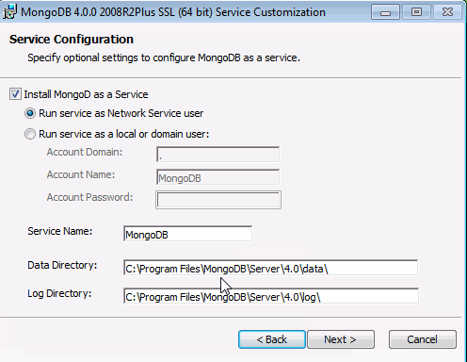
  - Select Install MongoD as a Service MongoDB as a service.
  - Select either:
    - Run the service as Network Service user (Default)
This is a Windows user account that is built-in to Windows
or
    - Run the service as a local or domain user
      - For an existing local user account, specify a period (i.e. .) for the Account Domain and specify the Account Name and the Account Password for the user.
      - For an existing domain user, specify the Account Domain, the Account Name and the Account Password for that user.
  - Service Name. Specify the service name. Default name is MongoDB. If you already have a service with the specified name, you must choose another name.
  - Data Directory. Specify the data directory, which corresponds to the --dbpath. If the directory does not exist, the installer will create the directory and sets the directory access to the service user.
  - Log Directory. Specify the Log directory, which corresponds to the --logpath. If the directory does not exist, the installer will create the directory and sets the directory access to the service user.
- Install MongoDB Compass
For Windows 8 or greater, you can have the wizard install MongoDB Compass. To install Compass, select Install MongoDB Compass (Default).
NOTE
The install script requires PowerShell version 3.0 or greater. If you have Windows 7, unclick the Install MongoDB Compass. You can manually download Compass from the Download Center.
- When ready, click Install.

If You Installed MongoDB as a Windows Service
The MongoDB service is started upon successful installation [1].
To begin using MongoDB, connect a mongo.exe shell to the running MongoDB instance. Either:
- From Windows Explorer/File Explorer, go to C:\Program Files\MongoDB\Server\4.2\bin\ directory and double-click on mongo.exe.
- Or, open a Command Interpreter with Administrative privileges and run:
- "C:\Program Files\MongoDB\Server\4.2\bin\mongo.exe"

Experiment – 2
Objective: To perform NoSQL database using mongodb to create Collection.
Output:
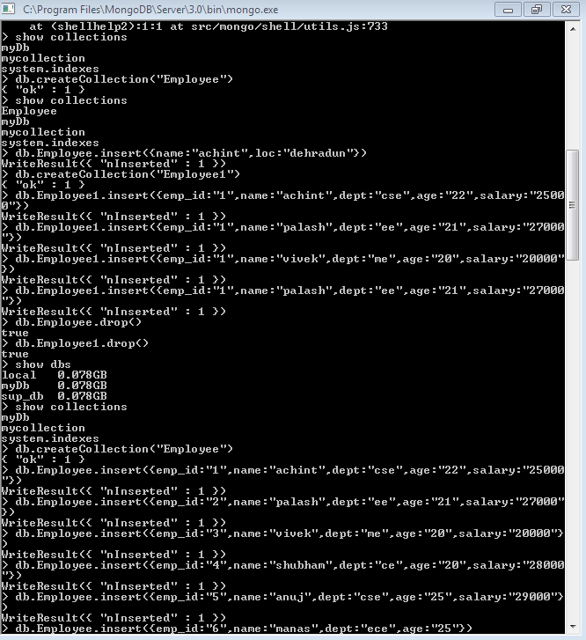

Experiment – 3
Objective: To perform NoSQL database using mongodb to drop collection.

Output:

Experiment – 4
Objective: To perform NoSQL database using mongodb to update and insert.

Output:
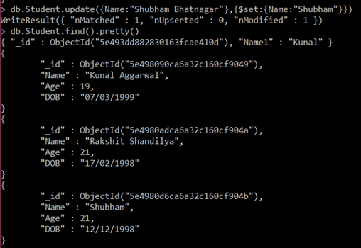

Experiment – 5
Objective: To perform MongoDB -Query Document The find() Method, The pretty() Method.
Output:
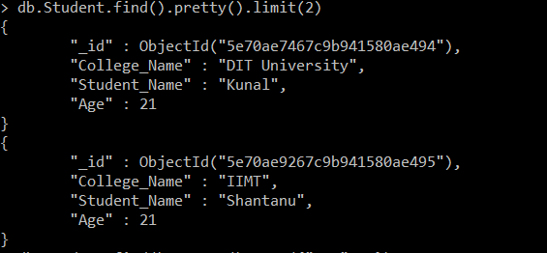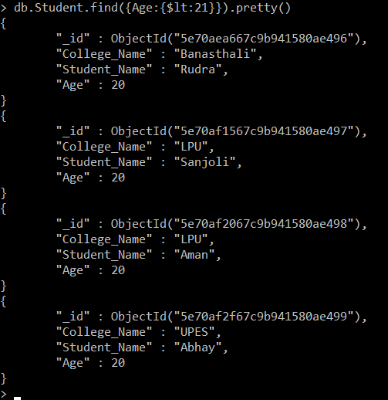

Experiment – 6
Objective: To perform MongoDB Limit Records, sort documents.

Output:

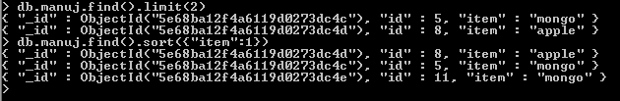

Experiment – 7
Objective: To perform simple R program by loading the data and present the class count of the data set
Step 1: Creating a dataset and loading.
COMMAND
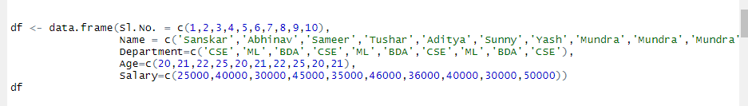
OUTPUT
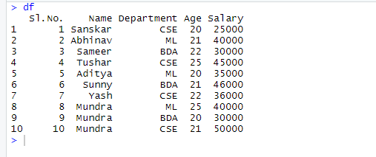
Step 2: Using the count class of the data set.
Part 1: Count the number of occurences.
COMMAND
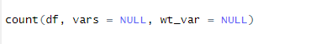
OUTPUT
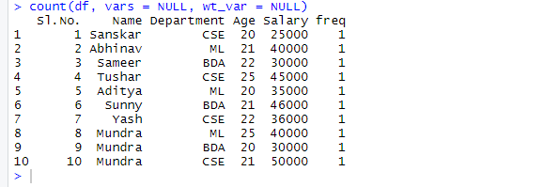
Part 2: Count of each value of "Name" in the first 10 cases
COMMAND
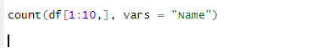
OUTPUT
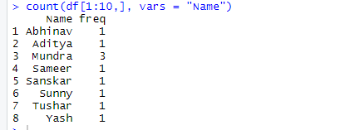

Experiment – 8
Objective: –Load any data set, Summarize the data set and plot with any graph

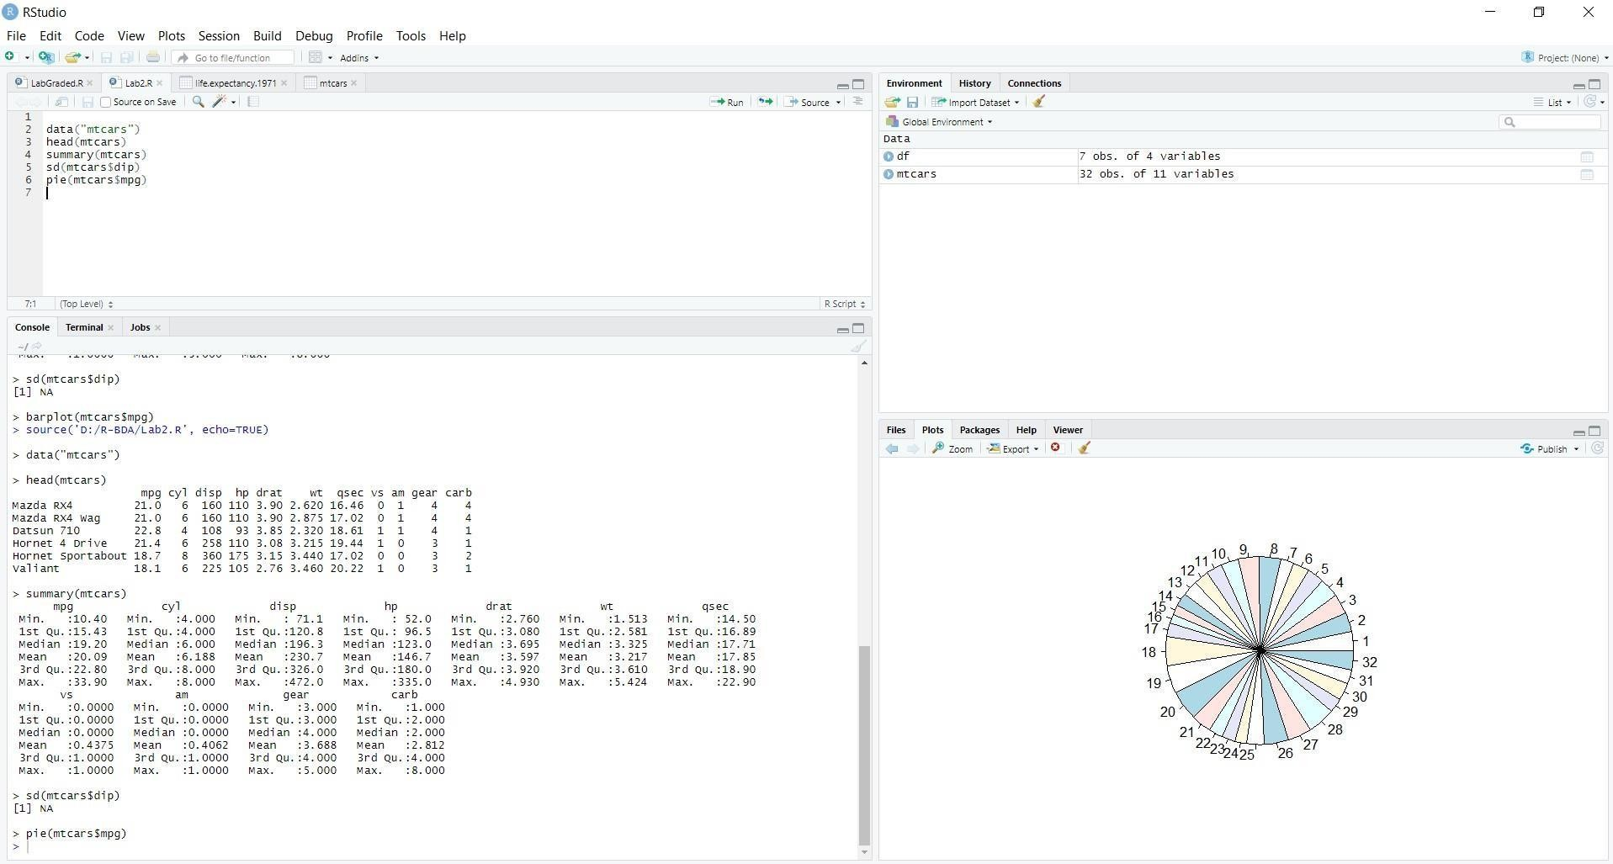
Output:

